Pacific Gas and Electric Company
Generating Stored Displays
Prepared by | Kris Foster
Date | 8/16/2013
Version | 1.4
Version Type | Final

Document Control

Change History
Author/Contributor | Version | Date | Description of Changes
Kris Foster | 1.0.0 | 6/20/2013 | Initial Document Creation
Kris Foster | 1.0.1 | 6/26/2013 | Updated with steps required for Circuit Map repairs
Kris Foser | 1.0.1 | 7/5/2013 | Updated with steps required for definition queries on circuit map repairs
Ashish Narasimham | 1.1 | 7/25/13 | Updated with validation steps to smoke test the stored displays
Don Peaslee | 1.2 | 8/16/2013 | Split out swizzle section 2.3 and 2.6 between ED Dataset and WIP cloud
Ashish Narasimham | 1.3 | 9/4/13 | Added step in to delete all current stored displays before saving new ones
Ashish Narasimham | 1.4 | 9/9/13 | Changed steps to retrieve styles for Circuit Map View circuit colors

Table of Contents
1. Objectives 4
1.1 Main Objectives 4
1.2 Intended Audience 4
2. Loading the stored displays 4
2.1 Copy the gold mxds locally 4
2.2 Open the “ED Master.mxd” 4
2.3 Make note of the broken data connection 4
2.4 Save the stored display 6
2.5 Repeat as necessary 6
2.6 Run the ArcFM Data Source Wizard tool 6
3. Special stored display considerations 8
3.1 Circuit Map 8

Objectives

Main Objectives
The objective of this document is to describe the process to load pre-configured stored displays into a new database instance. The steps provided should ensure that the stored displays in the new database are connected to the correct database and all layer configurations such as symbology are properly configured.

Intended Audience
The intended audience is any individual who is responsible for loading the stored displays into a database instance.

Loading the stored displays

Copy the gold mxds locally
Please identify the source of your MXD’s on the network and copy them locally to work with them.

Delete All Current mxd’s
Launch ArcMap.

Log in to ArcFM with a user that has the ability to create system stored displays.

Select the Stored Items drop down and select Stored Items Manager.

Expand System Stored Displays, select the first stored display, hold shift, select the last stored display, and click ‘Delete’ to delete all current System Stored Displays.

Open the mxd
Choose File->Open and browse to the mxd and click Open. When prompted with the spatial database connection login, click cancel.

Make note of the broken data connection

Electric Distribution (EDGIS schema)
The below section describes the steps to set the EDGIS feature classes

After performing the step above, the mxd should load and there should be several layers that have broken database connections.

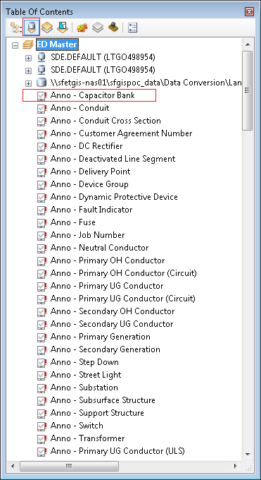
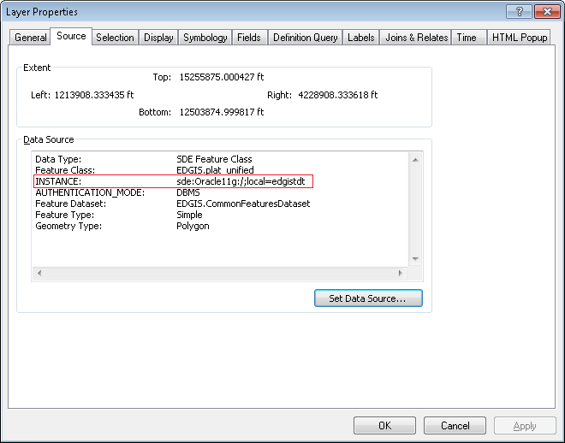
Right click on one of the red exclamation points next to a broken layer and click Properties. Select the Source tab. In the Data Source section make note of the instance parameter. This is a parameter that will be needed later in the process.

    - WIP
The below section describes the steps to set the WIP feature classes.
The below Stored Displays require the WIP swizzle.
1) Distribution Map View
2) ED Master
3) Streetlight Map

Right click and select properties on the WIP Label feature class
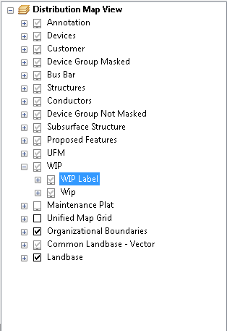

On the Source tabclick the “Set Data Source…” button.

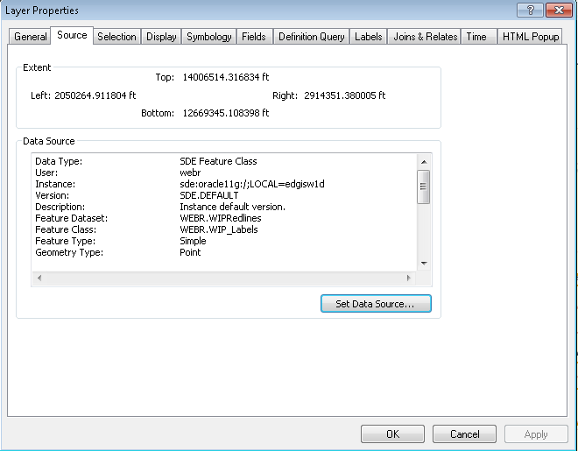

Navigate to the Database Connections folder and select the appropriate database (UID: webr PWD: webr)
1) Development: edgisw1D
2) Testing: edgisw1t
3) Training: edgiswtr
4) Production: edgisw1p
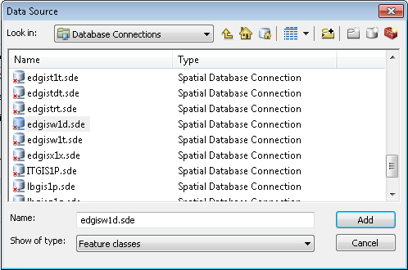

Navigate to the WIPDRedlines dataset and select the WIP_Labels feature class and click add.
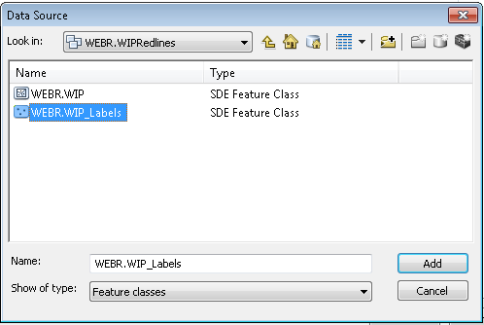
Click OK on the layer properites dialog.

Right click and select properties on the WIP feature class
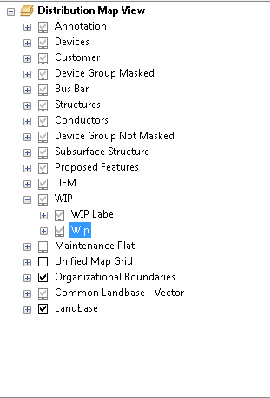

On the Source tabclick the “Set Data Source…” button.

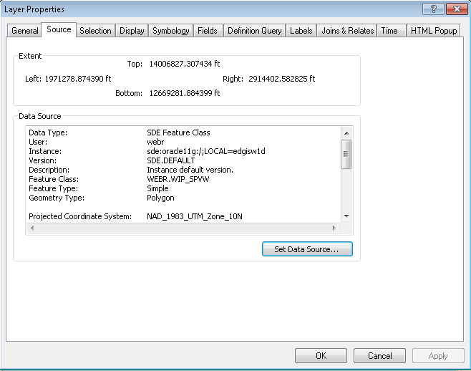

Navigate to the Database Connections folder and select the appropriate database (UID: webr PWD: webr)
1) Development: edgisw1D
2) Testing: edgisw1t
3) Training: edgiswtr
4) Production: edgisw1p

At the root level select WIP_SPVW and click add
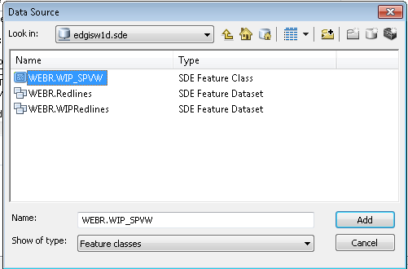

Click OK on the layer properites dialog.

Save the stored display
If it’s not already, add the “ArcFM” toolbar in ArcMap. This contains the stored items. Click the “Stored Items” drop down and select “Save as”.

This will open the “Save Stored Item As…” dialog.For Item type choose Stored Display. Select the system radio button. For name, enter the name of the mxd. For save in, choose the appropriate folder in the system stored items folder structure. Click OK. This will create the system stored display.
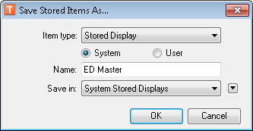

Repeat as necessary
Repeat steps 2.2-2.4 for all remaining mxds.

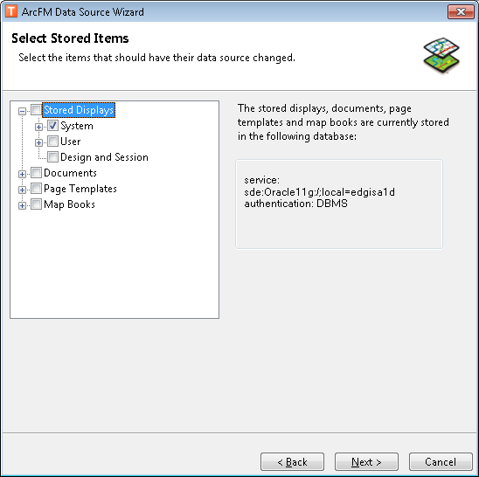
Run the ArcFM Data Source Wizard tool
Open ArcCatalog and connect to the database we just saved all of the stored displays to. Right click on the database and click “ArcFM Data Source Wizard”. This will open a new dialog. Click next on the welcome screen. The next screen will display the list of stored displays. Select all of the stored displays that were just created in the System stored displays list. Click Next.
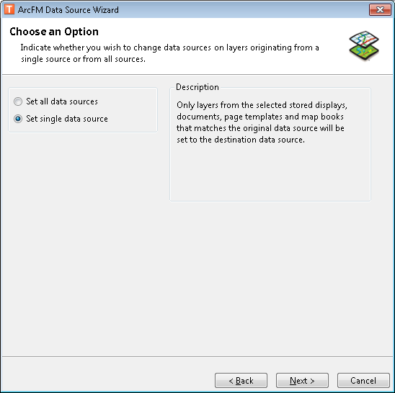
On the next page select “Set single data source”. Click Next.

Set the original datasource using the instance parameter that was made note of in step 2.3. Click Next.
The next screen is the destination data source. This should be already populated. Click Next.
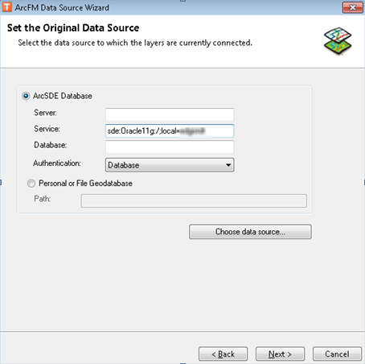
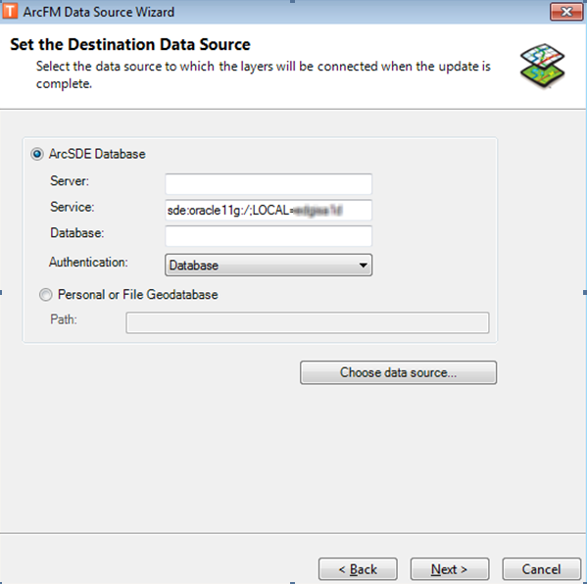
Click Next on the summary screen.
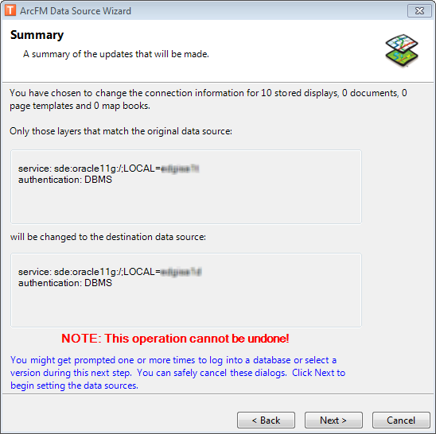
When prompted with any spatial database connections, click Cancel.
Note: If there are more than one instance that was noted in step 2.3 for any of the stored displays, then this step will need to be run once for each one.

Special stored display considerations

Circuit Map
The circuit map stored displays have joins specified to accommodate the symbology coloring of the different circuits. These joins and symbology will need to be fixed after the above steps. The following steps must be followed to repair this symbology.

- If the circuit map primary symbols have already been saved to the machine being worked on, then skip ahead to step 8.
- Navigate to the following location in Source Control:
http://edappgistfsprd1:8080/tfs/ElectricDistCollection/EDAMGIS/_versionControl#path=%24%2FEDAMGIS%2FSource_Development%2FConfiguration%2FArcMap%2FStored+Displays%2FEDER%2FStyle+File%2FCircuitColor.style&_a=contents
- Download the *.style file at that location.
- Log into ArcMap (as a user that can save System Stored Displays) and click Customize->Style Manager in the menu bar.
- Click ‘Styles…’ and then ‘Add Style to List…’.
- Navigate to the location of the *.style file that was downloaded from Source Control, select it, and click Open.
- Click ‘OK’ and ‘Close’. You now have the styles necessary to modify the Conductor layer symbology.
- Open the stored display with the broken circuit map symbology.
- Open the ‘List by Source’ tab in the table of contents
- Ensure that the ‘EDGIS.PGE_CIRCUITCOLOR’ table has been added to the map. If not, add it by right clicking on the parent source (i.e. “SDE.DEFAULT”) and choose ‘Add Table’. Then find the table and click ‘Add’.
- Go back to ‘List by Drawing Order’ in the table of contents
- Add the ‘Assign Color Code’ command to a toolbar if it has not been already.
- Right click on the “Primary Overhead Conductor 1 and 2 phase” and move the cursor over the ‘Joins and Relates -> Remove Joins’. If the PGE_CIRCUITCOLOR table is already listed then skip ahead to step 27
- Right click on the “Primary Overhead Conductor 1 and 2 phase” and click ‘Joins and Relates -> Join’.
- This opens the ‘Join Data’ dialog.
- For 1 choose ‘CircuitID’
- For 2 choose the ‘EDGIS.PGE_CIRCUITCOLOR’ table
- For 3 choose ‘CircuitID’
- Choose ‘Keep all records’
- Click Validate Join
- If the number of records matched equals the total number of records then cancel out of all Join Data dialogs and skip ahead to step 27
- Click close to the results dialog and then OK to the ‘Join Data’ page.
- Right click on the “Primary Overhead Conductor 1 and 2 phase” and click properties
- Open the symbology tab and ensure ‘Categories -> Unique Values’ is selected
- Click ‘Remove All’ to remove all the current symbols.
- For the ‘Value Field’ select ‘ColorCode’
- Click ‘Add All Values’ to add all of the unique values to the list.
- Right click on a symbol and choose ‘Properties for all symbols’
- Select the symbology that was saved earlier that correlated with the layer being fixed and click OK
- Double click the <all other values> symbol and choose the symbol that was saved earlier for this.
- Double click the <Null> symbol and choose the symbol that was saved earlier for this.
- Click OK
- Ensure the layer is selected in the table of contents and click the ‘Assign Color Code’ command.
- Repeat steps 17-37 for all other primary layers that need the circuit color symbology repaired.
- Right click on the circuit layer and choose properties
- Click on the definition query tab
- The definition queries can become incorrect when the joins are removed so ensure the definition queries are as follows for the following ciruit layers
Layer: Primary Overhead Conductor 1 and 2 Phase
Query: EDGIS.PriOHConductor.SUBTYPECD in (1,2) and Status IN (5,30,1,2,3)
Layer: Primary Overhead Conductor 3 Phase
Query: EDGIS.PriOHConductor.SUBTYPECD = 3 and Status IN (5,30,1,2,3)
Layer: Primary Underground Conductor 1 and 2 phase
Query: EDGIS.PriUGConductor.SUBTYPECD in (1,2) and Status IN (5,30,1,2,3)
Layer: Primary Underground Conductor 3 phase
Query: EDGIS.PriUGConductor.SUBTYPECD = 3 and Status IN (5,30,1,2,3)

Stored Displays Smoke Test

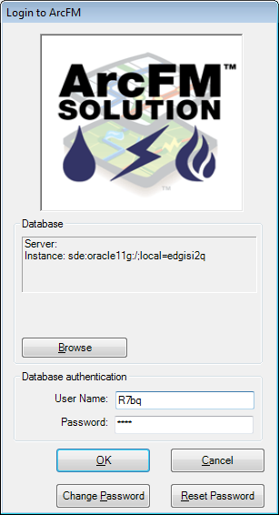
After completing all stored display generation, complete the following steps to validate that the correct settings have been put into the instance
- Login to ArcFM with a general user
- Click the dropdown next to “Stored Items” to bring up a list of the system stored displays.
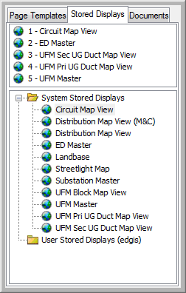
Validation: 11 system stored displays exist. (Note: 11 is the number of stored displays that are in use at the time of this document’s creation. The number could change)
- Open each stored display and perform the following actions:
Validation: Connection dialog does not appear upon opening the stored display
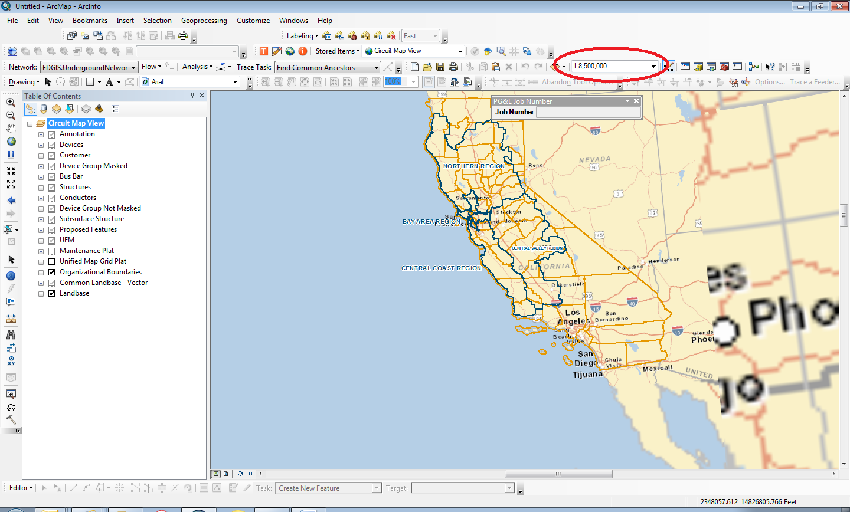
Validation: View extent is 1:8,500,000

Validation: The database connection of any electric feature is correct based on the database you have logged into and the user name is the user used to login. (Do not use the “edgis” user). Validation: The “Instance:” string is ‘sde:oracle11g:/;local=’<database>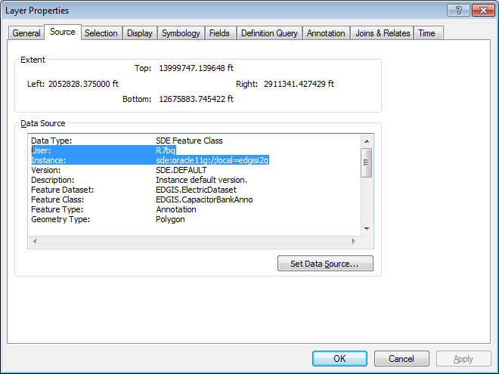

Validation: Landbase features are pointed to ‘lbgis1p’ user ‘LBGIS_RO’
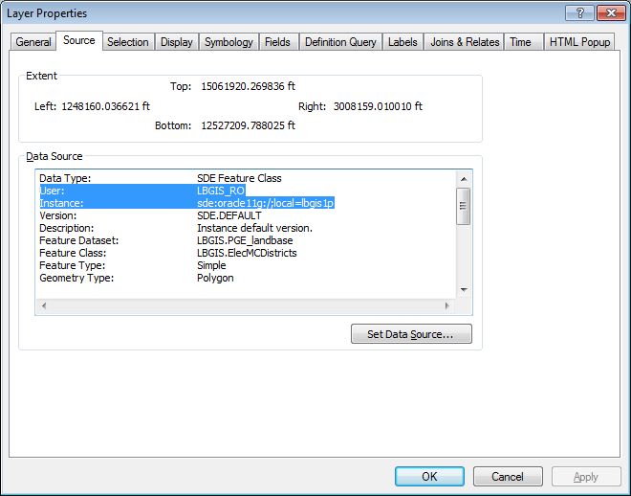

- Navigate to the “Sources” tab in the Table of Contents.
Validate the below connection groups. To do this, locate each data source. Data sources should begin with “SDE.DEFAULT…”. Under each data source, right click a layer and go to “Properties”. After navigating to the “Source” tab, verify that the stored display you are in contains layers from each of the instances listed below.
For example, Circuit Map View should have Electric Data from A1D, A1T, etc. (which ever database you are in), land base data from LBGIS1P, and the website referenced in the last column (http://wwwlbgis/arcgis/services).

 | Electric Data (A1D, A1T, …) | edgisw1d | lbgis1p | http://wwwlbgis/arcgis/services
Circuit Map View | X |  | X | X
Distribution Map View (M&C) | X |  | X | X
Distribution Map View | X | X | X | X
ED Master | X | X | X | X
Landbase | X |  | X | X
Streetlight Map | X | X | X | X
Substation Master | X |  | X | X
UFM Block Map View | X |  | X | X
UFM Master | X |  | X | X
UFM Pri UG Duct Map View | X |  | X | X
UFM Sec UG Duct Map View | X |  | X | X
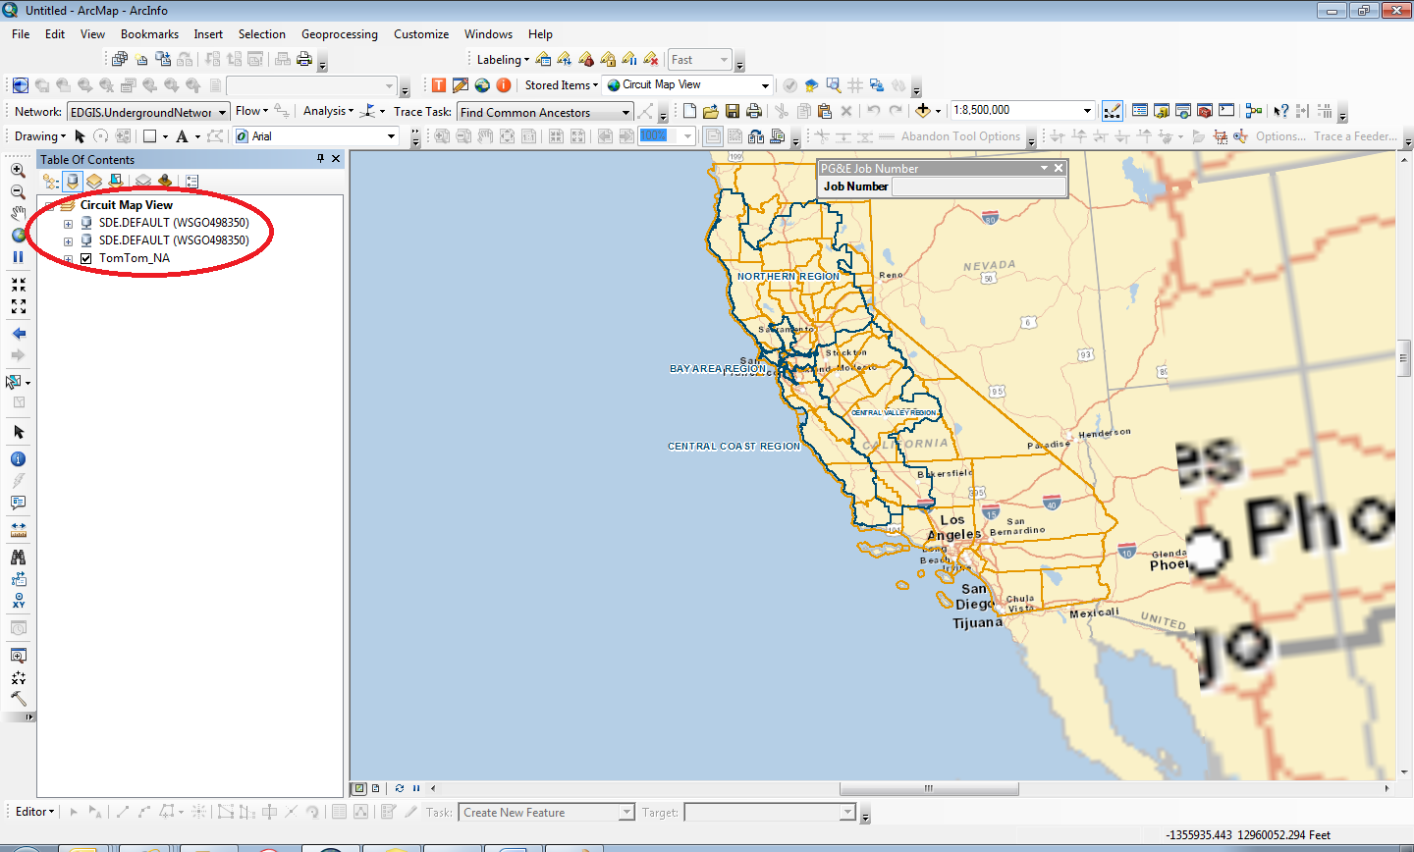

- Zoom into an area on the map containing data until your zoom level is less than 1:6000. At this point, the landbase cache is suppressed in favor of the actual electrical assets.
Validate the fonts: If you see large “E”s, this is an incorrect TTF installed when saving the stored display. This validation can be done on all stored displays except the landbase and UFM stored displays (these all currently only have landbase features). An example of ED Master is below
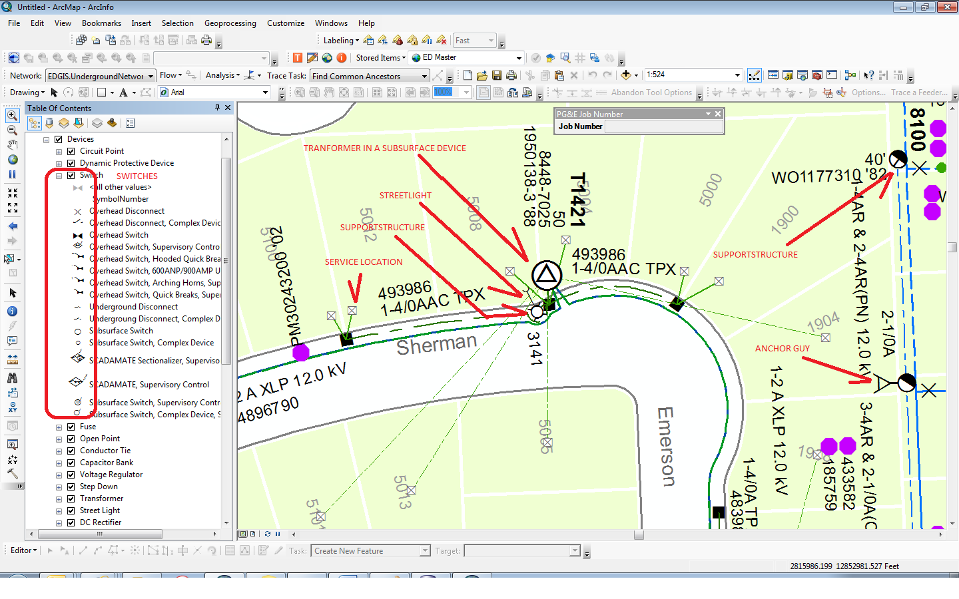

- CIRCUIT MAP VIEW ONLY – Validate all 4 primary conductors have the correct symbology (ignore color at this time)
  - Primary Overhead Conductor 1 and 2 phase – Dashed line
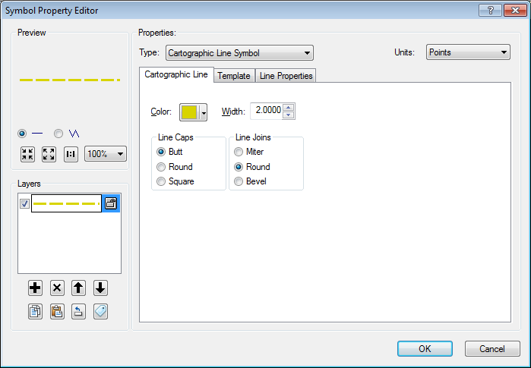

  - Primary Overhead Conductor 3 phase – Solid line
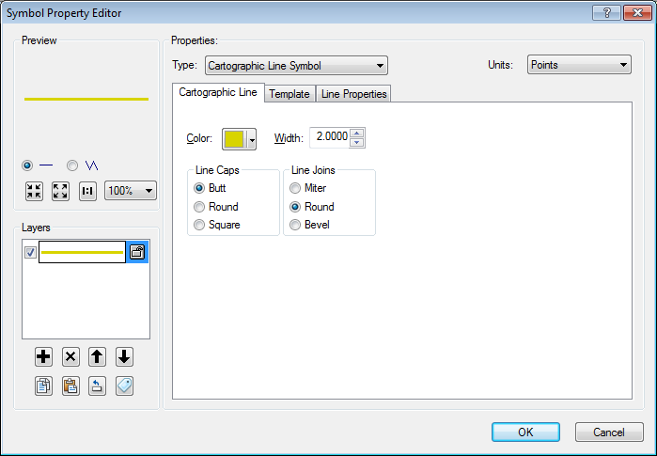

  - Primary Underground Conductor 1 and 2 phase – Dashed line with cross hatches
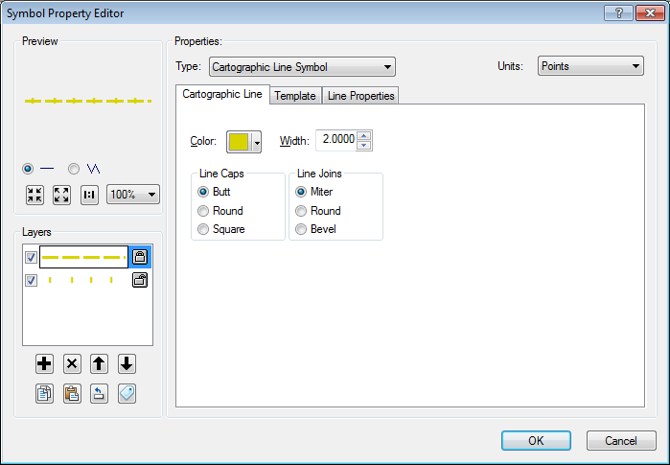

  - Primary Underground Conductor 3 phase – Solid line with cross hatches

- Validate the “color code” on all four primary conductors. Go to the layer properties, symbology tab. Validate the ‘COLORCODE’ is the “Value Field” and that there are a series of numbers. “<all other values>” and “<Null>” should be set to “?” Validate COLORCODE 2 (circuit 163191712) is set to R=127 G=31 B=0 and COLORCODE 33 (circuit 252211103) is set to R=0 G=0 B=128

